Lab Assisgnment- 10.2
Program : B. Tech (CSE)
Specializa on : AIML
Course Title : AI Assisted coding
Semester : III
Academic Session : 2025-2026
Name of Student : Md heena
Enrollment No : 2403A54067
Batch No. : 01
Date : 07-10-2025
Task Description#1 AI-Assisted
Code Review (Basic Errors)
- Write python program as shown below.
- Use an AI assistant to review and suggest correc ons
Expected Outcome#1: Students need to submit corrected code with comments
Prompt :
Here's a Python program wri en to calculate the factorial of a number. The loop uses the variable i, but the goal is to rewrite or correct the code without using i as a loop variable. Also, please check for any basic errors and suggest improvements with comments.
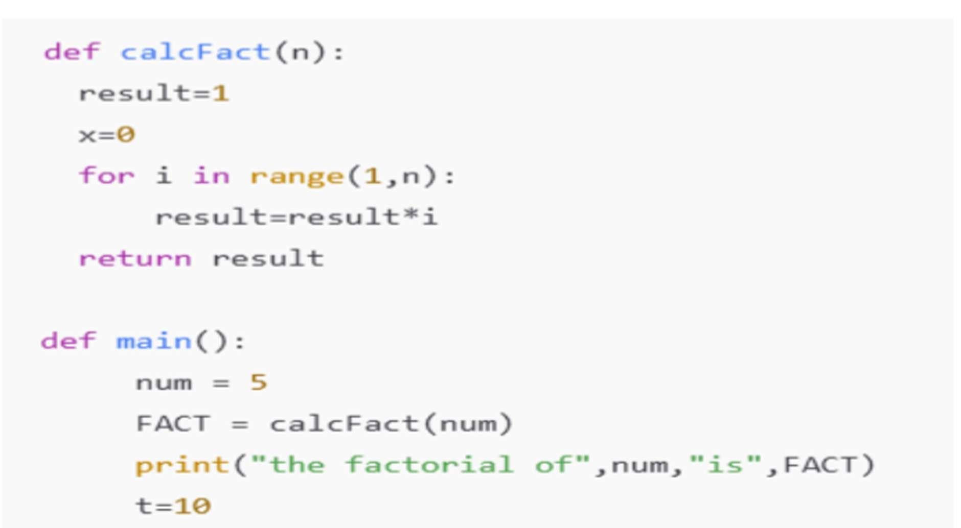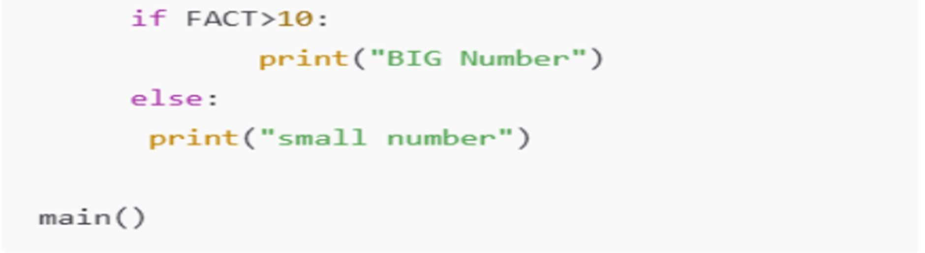
Corrected code:
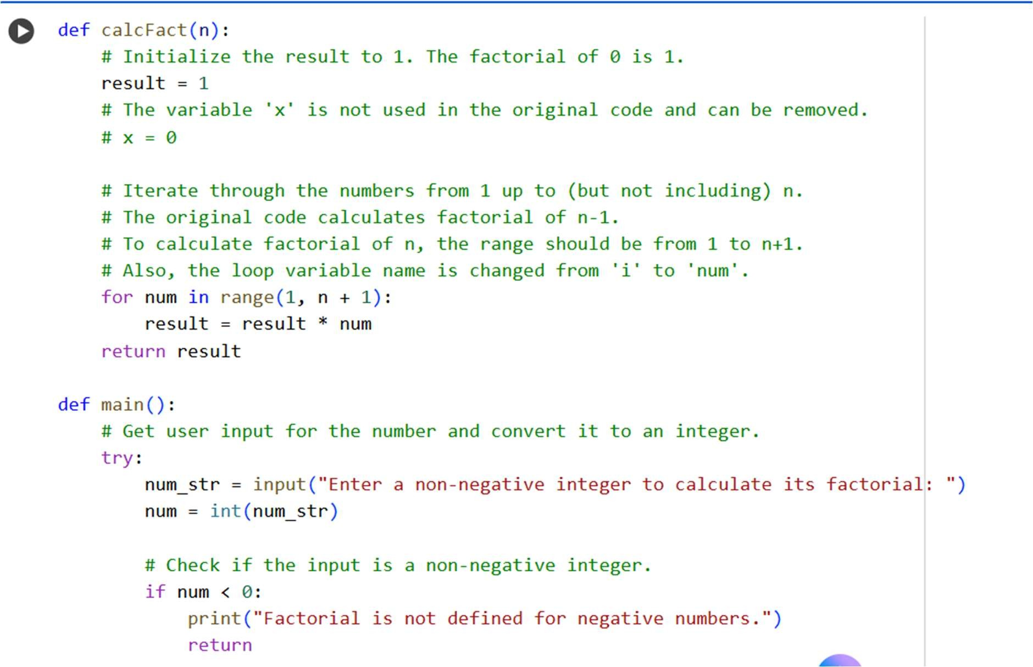
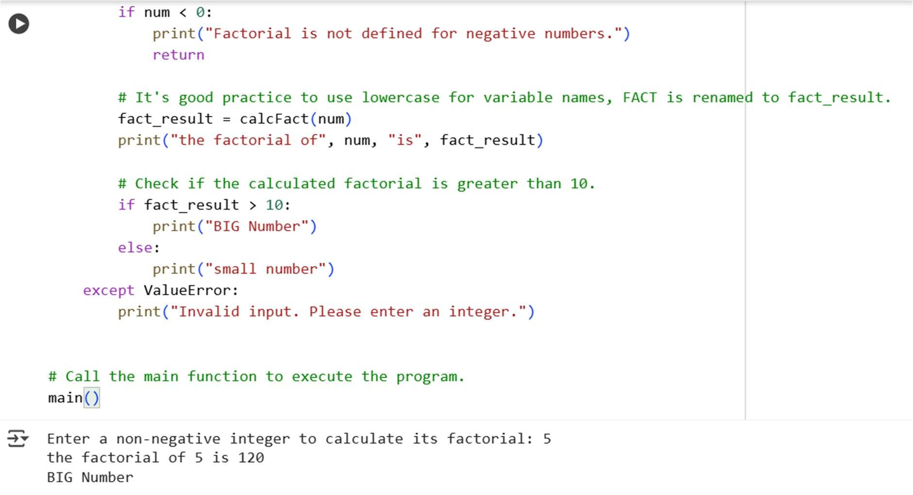
Task Description#2 Automatic Inline Comments
- Write the Python code for Fibonacci as shown below and execute.
- Ask AI to improve variable names, add comments, and apply PEP8 forma ng
(cleaned up).
- Students evaluate which sugges ons improve readability most. One Expected Output#2: Clean format python code with much readability.
Prompt:
A Python program has been wri en to calculate the sum of Fibonacci numbers up to a given count. The task involves improving the code by: - Replacing unclear variable names - Adding meaningful comments - Applying PEP8 forma ng The loop currently uses the variable i, which should be avoided. review the code and suggest a corrected version with be er readability:
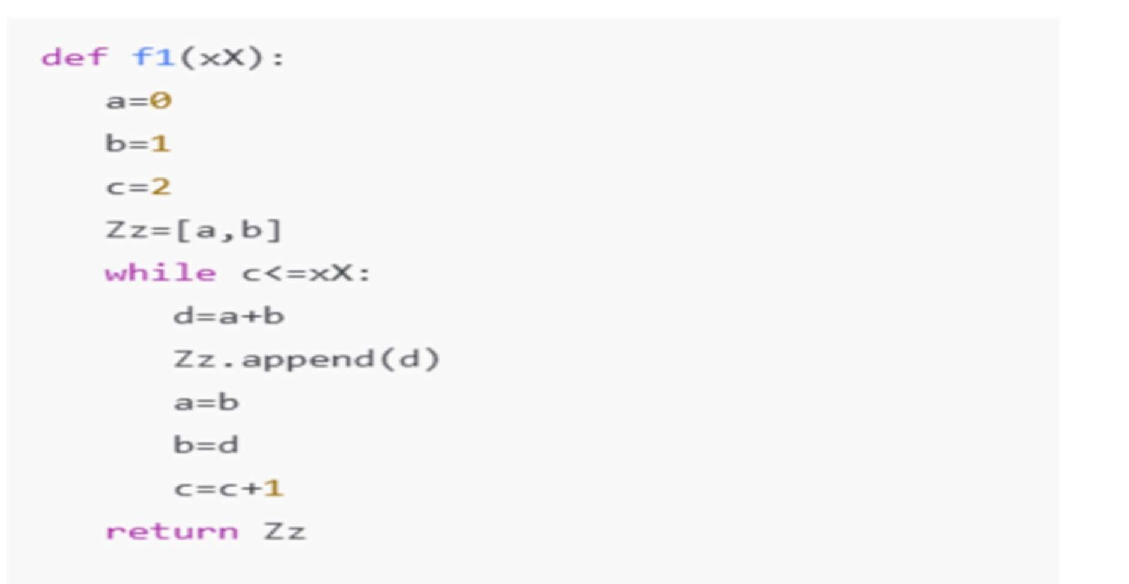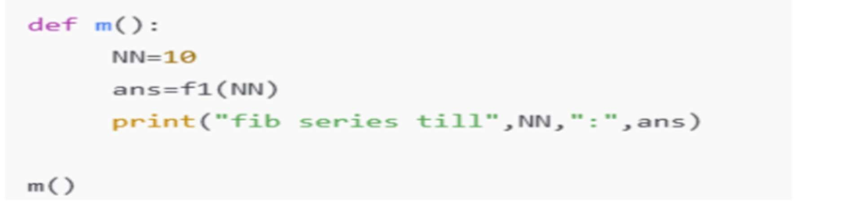
Corrected code:
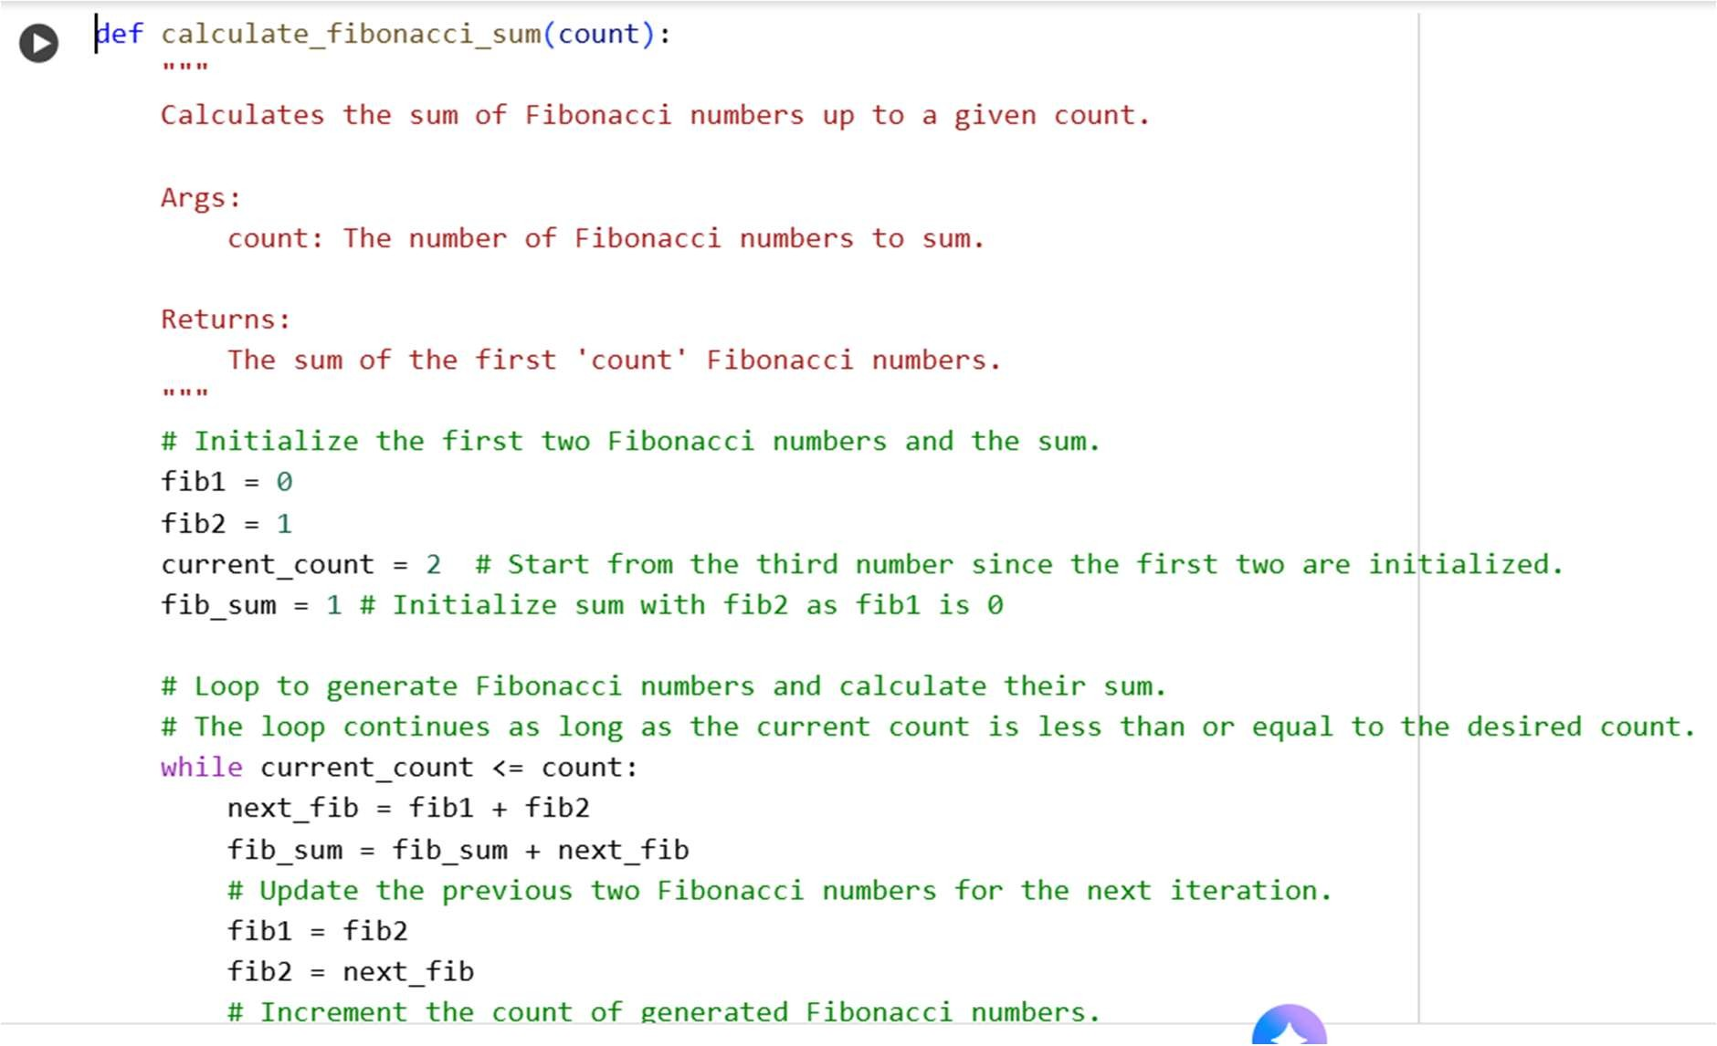
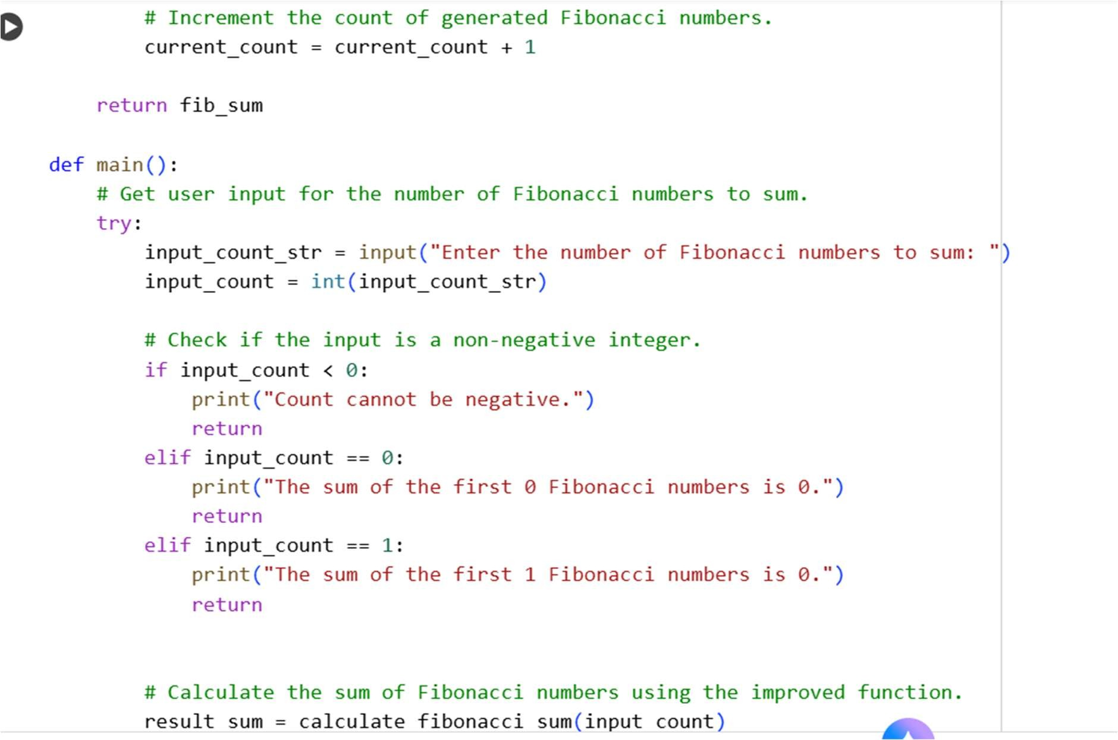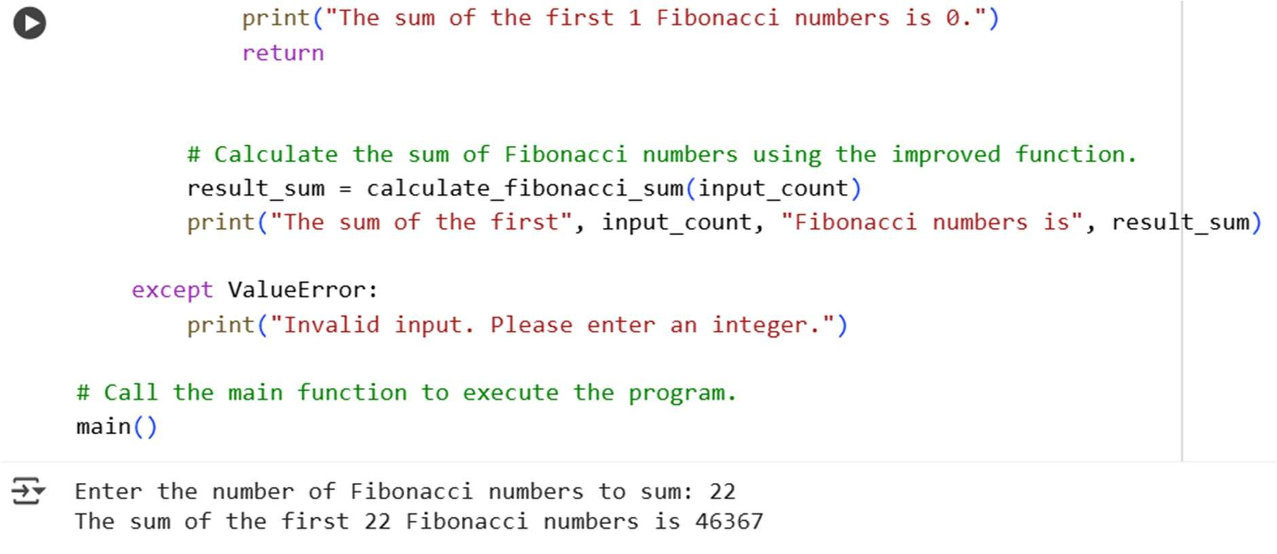
Task Description#3
- Write a Python script with 3–4 func ons (e.g., calculator: add, subtract, mul ply, divide).
- Incorporate manual docstring in code with NumPy Style
- Use AI assistance to generate a module-level docstring + individual func on docstrings.
- Compare the AI-generated docstring with your manually wri en one
Common Examples of Code Smells
- Long Func on – A single func on tries to do too many things.
- Duplicate Code – Copy-pasted logic in mul ple places.
- Poor Naming – Variables or func ons with confusing names (x1, foo, data123).
- Unused Variables – Declaring variables but never using them.
- Magic Numbers – Using unexplained constants (3.14159 instead of PI).
- Deep Nes ng – Too many if/else levels, making code hard to read.
- Large Class – A single class handling too many responsibili es.
Why Detec ng Code Smells is Important
- Makes code easier to read and maintain.
- Reduces chance of bugs in future updates.
- Helps in refactoring (improving structure without changing behavior)
- Encourages clean coding prac ces
Dead Code – Code that is never executed.
Expected Output#3: Students learn structured documenta on for mul -func on scripts
Prompt:
Create a python program with four func ons: add, subtract, mul ply, and divide. Each func on includes a manually wri en docstring using NumPy style.
Assistance is requested to:
  - Generate a module-level docstring
  - Rewrite each func on’s docstring using NumPy style
  - Iden fy any code smells such as long func ons, duplicate logic, poor naming, unused variables, magic numbers, deep nes ng, or dead code
  - Suggest improvements for readability and structure
A comparison will be made between manually wri en docstrings and those generated by the assistant to evaluate clarity and effec veness.
Code:
First function: Addition
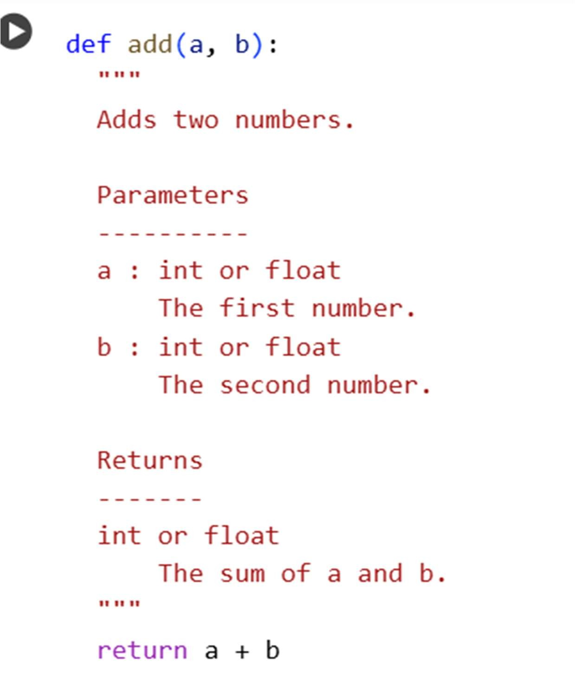
Second Function: Subtraction
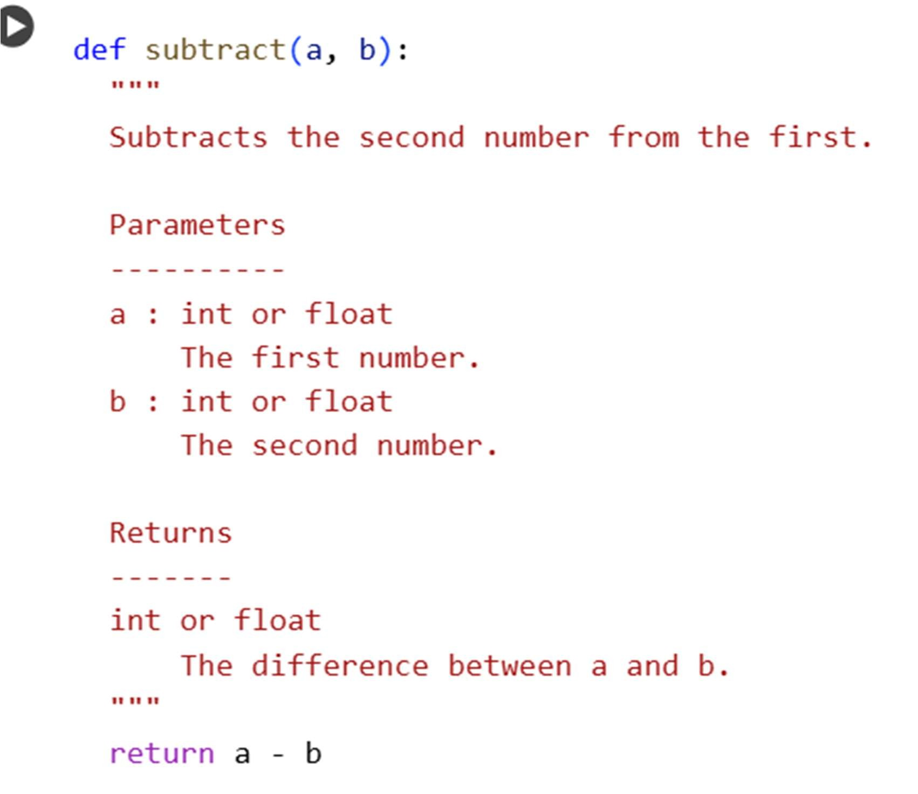
Third function: Multiplication
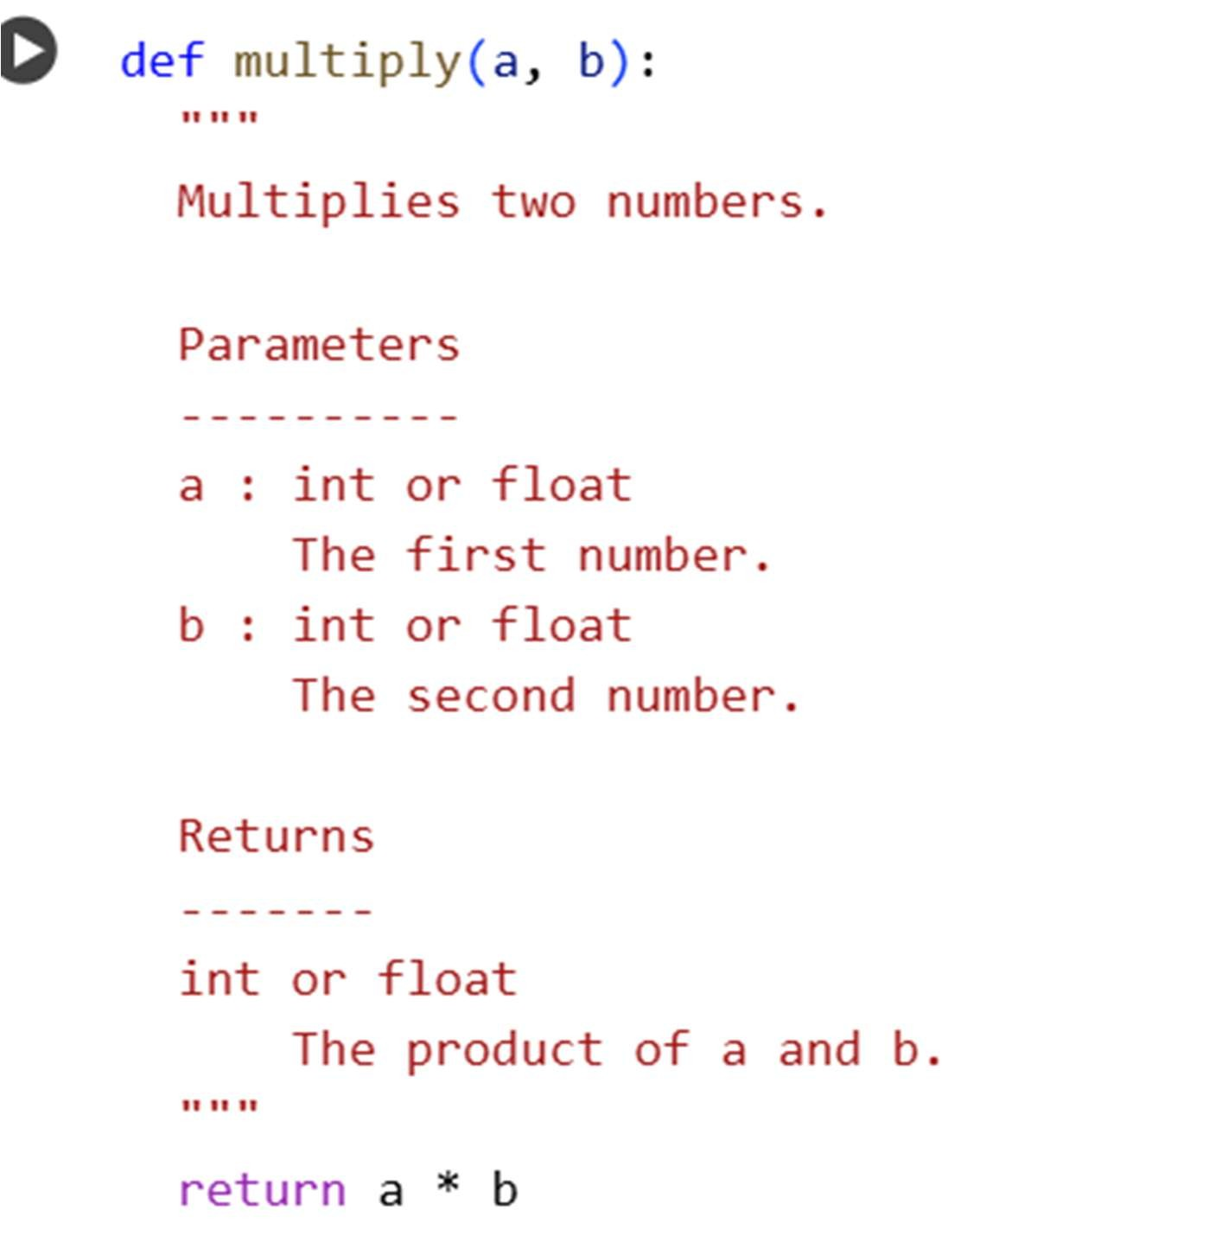
Fourth function: Division
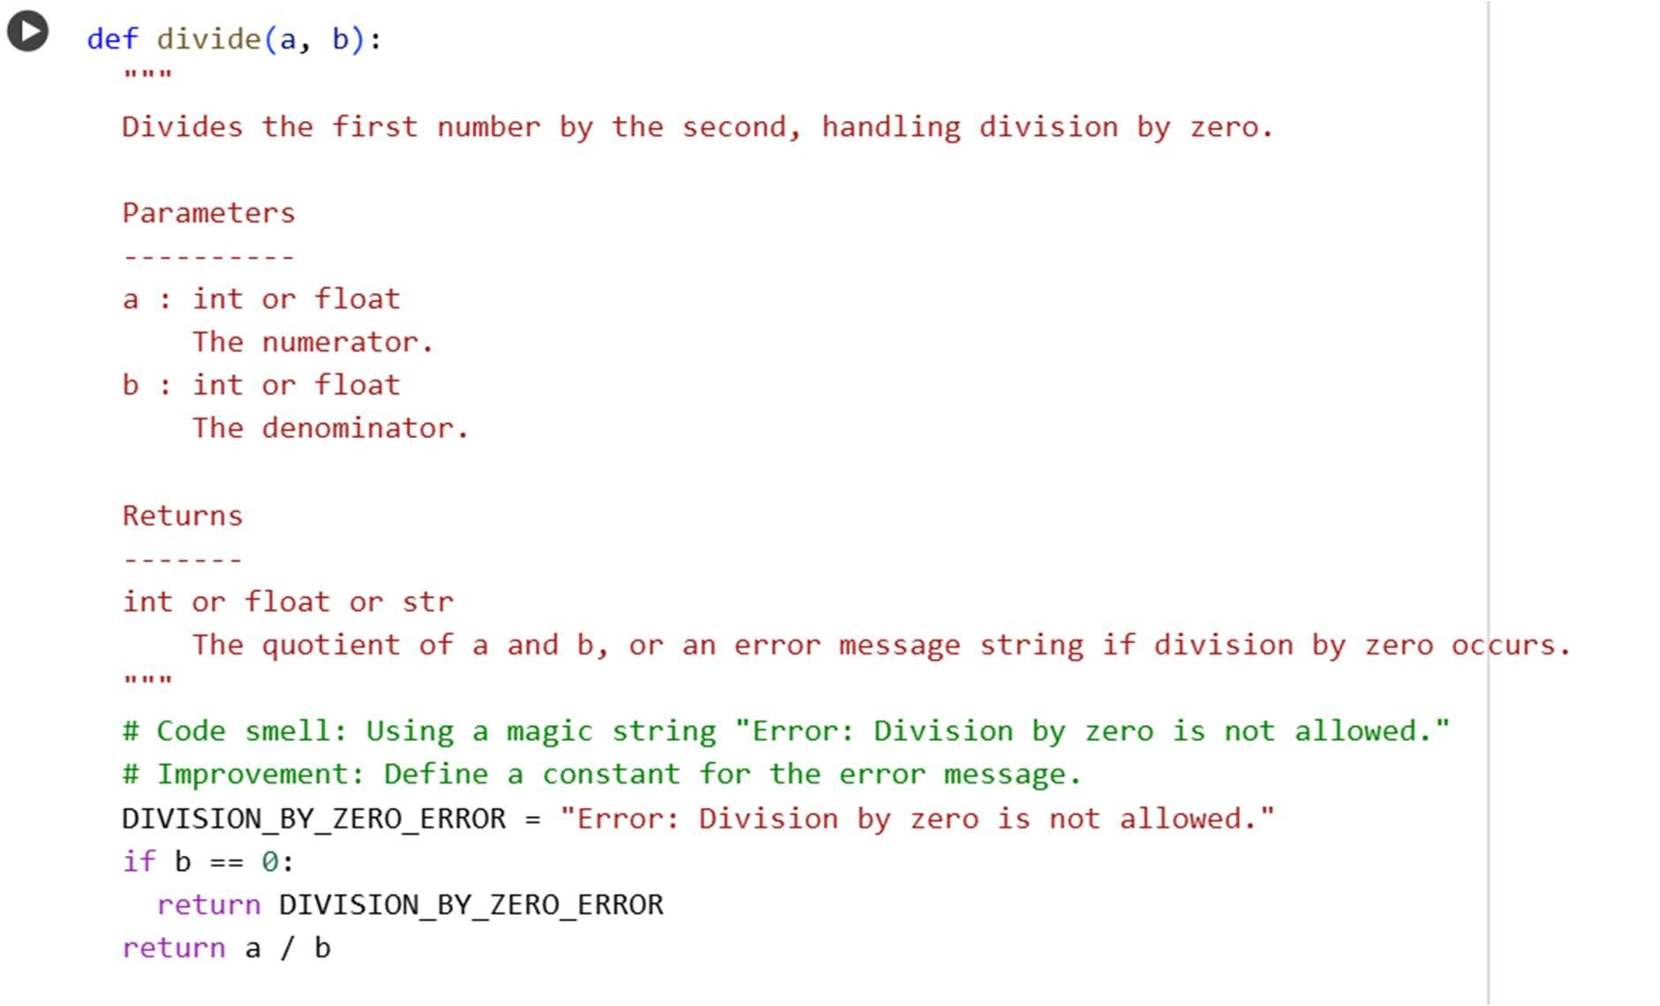
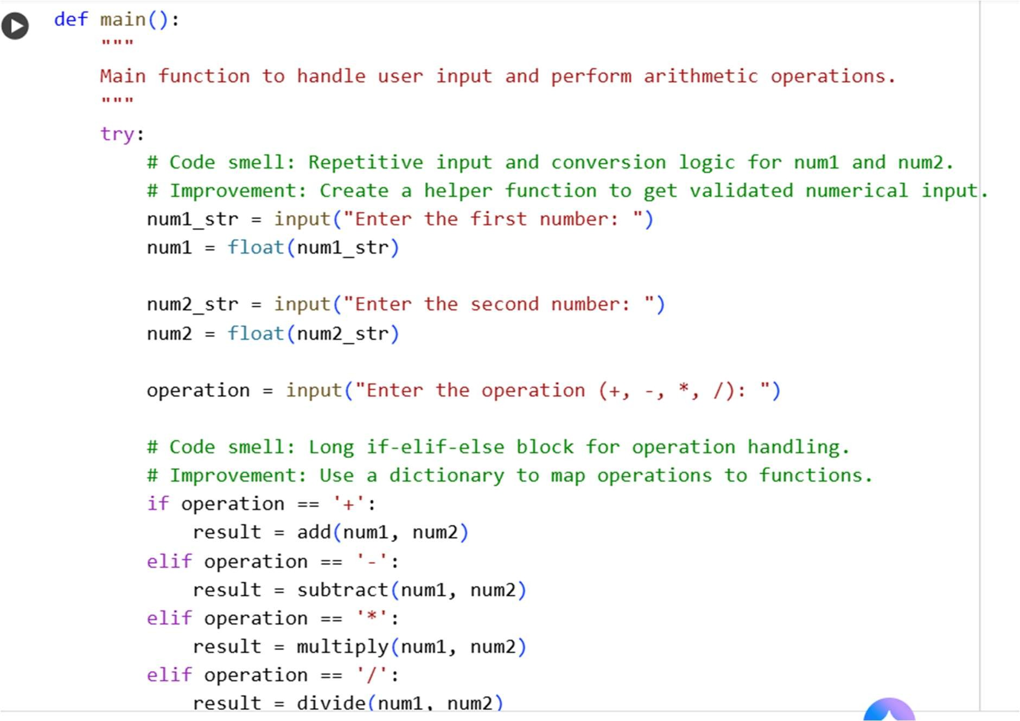
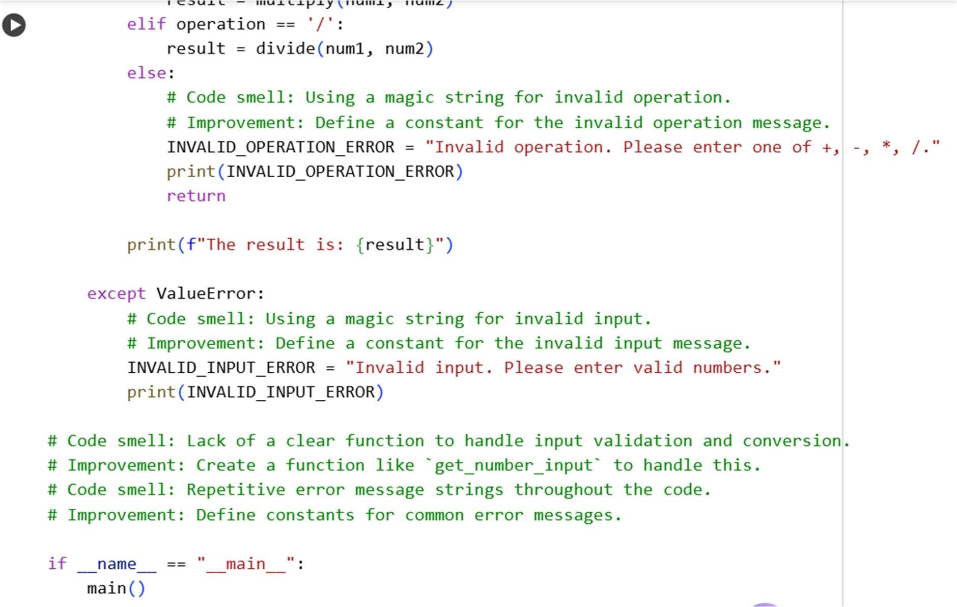
Output:

